Experiment – 16

Aim
To compare the performance of Decision Tree and K-Nearest Neighbour (KNN) classification algorithms using five different datasets and determine which algorithm provides better classification performance based on accuracy.

Algorithm
- Import the required Python libraries such as DecisionTreeClassifier, KNeighborsClassifier, train_test_split, and accuracy_score.
- Create the five datasets with their input features and target labels.
- Separate each dataset into:
  - X – Input features
  - y – Target variable
- Split each dataset into training and testing sets using train_test_split().
- Create and train a Decision Tree classifier using the training data.
- Create and train a KNN classifier using the training data.
- Predict the classes of the test data using both classifiers.
- Calculate the accuracy of both Decision Tree and KNN.
- Predict the class of the given new sample using both models.
- Compare the accuracies and identify the better-performing algorithm for each dataset.
- Display the prediction and accuracy results.

Program:
# ============================================================
# EXPERIMENT 16
# COMPARISON OF DECISION TREE AND KNN CLASSIFICATION
# ============================================================

from sklearn.tree import DecisionTreeClassifier
from sklearn.neighbors import KNeighborsClassifier
from sklearn.model_selection import train_test_split
from sklearn.metrics import accuracy_score

# ============================================================
# DATASET 1: STUDENT PLACEMENT PREDICTION
# ============================================================

print("=" * 65)
print("DATASET 1: STUDENT PLACEMENT PREDICTION")
print("=" * 65)

X1 = [
[9.2, 90, 88],
[8.8, 85, 82],
[8.5, 80, 79],
[7.2, 72, 70],
[6.8, 68, 65],
[9.0, 92, 90],
[7.5, 75, 74],
[8.6, 84, 81],
[6.5, 60, 58],
[8.9, 88, 86]
]

y1 = [
"Placed", "Placed", "Placed", "Not Placed", "Not Placed",
"Placed", "Not Placed", "Placed", "Not Placed", "Placed"
]

X_train, X_test, y_train, y_test = train_test_split(
X1, y1, test_size=0.3, random_state=42
)

dt1 = DecisionTreeClassifier(random_state=42)
knn1 = KNeighborsClassifier(n_neighbors=3)

dt1.fit(X_train, y_train)
knn1.fit(X_train, y_train)

dt_pred = dt1.predict(X_test)
knn_pred = knn1.predict(X_test)

dt_acc1 = accuracy_score(y_test, dt_pred)
knn_acc1 = accuracy_score(y_test, knn_pred)

new_sample1 = [[8.7, 86, 84]]

print("Decision Tree Accuracy:", dt_acc1 * 100, "%")
print("KNN Accuracy:", knn_acc1 * 100, "%")
print("Decision Tree Prediction:", dt1.predict(new_sample1)[0])
print("KNN Prediction:", knn1.predict(new_sample1)[0])

# ============================================================
# DATASET 2: LOAN APPROVAL PREDICTION
# ============================================================

print("\n" + "=" * 65)
print("DATASET 2: LOAN APPROVAL PREDICTION")
print("=" * 65)

X2 = [
[8, 780, 5],
[7, 760, 4],
[6, 730, 5],
[4, 620, 8],
[3, 590, 9],
[9, 810, 4],
[5, 650, 7],
[8, 770, 5],
[4, 610, 8],
[7, 750, 6]
]

y2 = [
"Approved", "Approved", "Approved", "Rejected", "Rejected",
"Approved", "Rejected", "Approved", "Rejected", "Approved"
]

X_train, X_test, y_train, y_test = train_test_split(
X2, y2, test_size=0.3, random_state=42
)

dt2 = DecisionTreeClassifier(random_state=42)
knn2 = KNeighborsClassifier(n_neighbors=3)

dt2.fit(X_train, y_train)
knn2.fit(X_train, y_train)

dt_pred = dt2.predict(X_test)
knn_pred = knn2.predict(X_test)

dt_acc2 = accuracy_score(y_test, dt_pred)
knn_acc2 = accuracy_score(y_test, knn_pred)

new_sample2 = [[7, 760, 5]]

print("Decision Tree Accuracy:", dt_acc2 * 100, "%")
print("KNN Accuracy:", knn_acc2 * 100, "%")
print("Decision Tree Prediction:", dt2.predict(new_sample2)[0])
print("KNN Prediction:", knn2.predict(new_sample2)[0])

# ============================================================
# DATASET 3: DISEASE DIAGNOSIS
# ============================================================

print("\n" + "=" * 65)
print("DATASET 3: DISEASE DIAGNOSIS")
print("=" * 65)

X3 = [
[39.0, 110, 94],
[38.5, 108, 95],
[37.0, 78, 99],
[39.2, 115, 93],
[36.8, 75, 98],
[38.8, 112, 94],
[37.2, 80, 98],
[39.1, 114, 92],
[36.7, 74, 99],
[38.9, 111, 93]
]

y3 = [
"Positive", "Positive", "Negative", "Positive", "Negative",
"Positive", "Negative", "Positive", "Negative", "Positive"
]

X_train, X_test, y_train, y_test = train_test_split(
X3, y3, test_size=0.3, random_state=42
)

dt3 = DecisionTreeClassifier(random_state=42)
knn3 = KNeighborsClassifier(n_neighbors=3)

dt3.fit(X_train, y_train)
knn3.fit(X_train, y_train)

dt_pred = dt3.predict(X_test)
knn_pred = knn3.predict(X_test)

dt_acc3 = accuracy_score(y_test, dt_pred)
knn_acc3 = accuracy_score(y_test, knn_pred)

new_sample3 = [[38.7, 109, 94]]

print("Decision Tree Accuracy:", dt_acc3 * 100, "%")
print("KNN Accuracy:", knn_acc3 * 100, "%")
print("Decision Tree Prediction:", dt3.predict(new_sample3)[0])
print("KNN Prediction:", knn3.predict(new_sample3)[0])

# ============================================================
# DATASET 4: EMPLOYEE PROMOTION PREDICTION
# ============================================================

print("\n" + "=" * 65)
print("DATASET 4: EMPLOYEE PROMOTION PREDICTION")
print("=" * 65)

X4 = [
[10, 95, 50],
[8, 90, 45],
[7, 88, 40],
[3, 65, 20],
[2, 60, 18],
[9, 93, 48],
[4, 70, 25],
[8, 89, 42],
[2, 58, 15],
[6, 85, 38]
]

y4 = [
"Promoted", "Promoted", "Promoted", "Not Promoted",
"Not Promoted", "Promoted", "Not Promoted",
"Promoted", "Not Promoted", "Promoted"
]

X_train, X_test, y_train, y_test = train_test_split(
X4, y4, test_size=0.3, random_state=42
)

dt4 = DecisionTreeClassifier(random_state=42)
knn4 = KNeighborsClassifier(n_neighbors=3)

dt4.fit(X_train, y_train)
knn4.fit(X_train, y_train)

dt_pred = dt4.predict(X_test)
knn_pred = knn4.predict(X_test)

dt_acc4 = accuracy_score(y_test, dt_pred)
knn_acc4 = accuracy_score(y_test, knn_pred)

new_sample4 = [[7, 90, 44]]

print("Decision Tree Accuracy:", dt_acc4 * 100, "%")
print("KNN Accuracy:", knn_acc4 * 100, "%")
print("Decision Tree Prediction:", dt4.predict(new_sample4)[0])
print("KNN Prediction:", knn4.predict(new_sample4)[0])

# ============================================================
# DATASET 5: VEHICLE CLASSIFICATION
# ============================================================

print("\n" + "=" * 65)
print("DATASET 5: VEHICLE CLASSIFICATION")
print("=" * 65)

X5 = [
[100, 95, 70],
[125, 110, 65],
[150, 125, 55],
[800, 850, 22],
[1000, 950, 20],
[1200, 1050, 18],
[110, 100, 68],
[900, 900, 21],
[140, 120, 58],
[1300, 1100, 17]
]

y5 = [
"Bike", "Bike", "Bike", "Car", "Car",
"Car", "Bike", "Car", "Bike", "Car"
]

X_train, X_test, y_train, y_test = train_test_split(
X5, y5, test_size=0.3, random_state=42
)

dt5 = DecisionTreeClassifier(random_state=42)
knn5 = KNeighborsClassifier(n_neighbors=3)

dt5.fit(X_train, y_train)
knn5.fit(X_train, y_train)

dt_pred = dt5.predict(X_test)
knn_pred = knn5.predict(X_test)

dt_acc5 = accuracy_score(y_test, dt_pred)
knn_acc5 = accuracy_score(y_test, knn_pred)

new_sample5 = [[135, 118, 60]]

print("Decision Tree Accuracy:", dt_acc5 * 100, "%")
print("KNN Accuracy:", knn_acc5 * 100, "%")
print("Decision Tree Prediction:", dt5.predict(new_sample5)[0])
print("KNN Prediction:", knn5.predict(new_sample5)[0])

# ============================================================
# FINAL COMPARISON
# ============================================================

print("\n")
print("=" * 65)
print("FINAL ACCURACY COMPARISON")
print("=" * 65)

print("\nDataset Decision Tree KNN")
print("-" * 65)

print("1. Student Placement ",
f"{dt_acc1*100:.2f}%", " ",
f"{knn_acc1*100:.2f}%")

print("2. Loan Approval ",
f"{dt_acc2*100:.2f}%", " ",
f"{knn_acc2*100:.2f}%")

print("3. Disease Diagnosis ",
f"{dt_acc3*100:.2f}%", " ",
f"{knn_acc3*100:.2f}%")

print("4. Employee Promotion ",
f"{dt_acc4*100:.2f}%", " ",
f"{knn_acc4*100:.2f}%")

print("5. Vehicle Classification ",
f"{dt_acc5*100:.2f}%", " ",
f"{knn_acc5*100:.2f}%")

# ============================================================
# DETERMINE BETTER ALGORITHM FOR EACH DATASET
# ============================================================

print("\n" + "=" * 65)
print("BETTER PERFORMING ALGORITHM")
print("=" * 65)

datasets = [
("Student Placement", dt_acc1, knn_acc1),
("Loan Approval", dt_acc2, knn_acc2),
("Disease Diagnosis", dt_acc3, knn_acc3),
("Employee Promotion", dt_acc4, knn_acc4),
("Vehicle Classification", dt_acc5, knn_acc5)
]

for name, dt_acc, knn_acc in datasets:

if dt_acc > knn_acc:
better = "Decision Tree"
elif knn_acc > dt_acc:
better = "KNN"
else:
better = "Both are equal"

print(f"{name}: {better}")

Output:
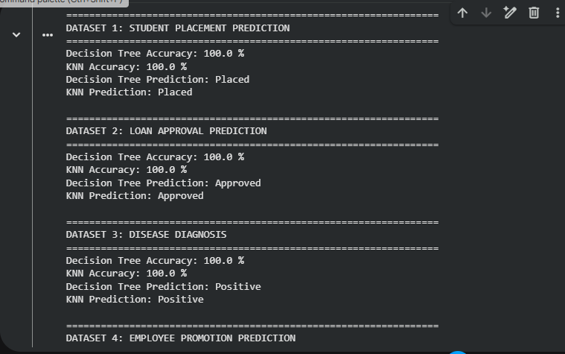
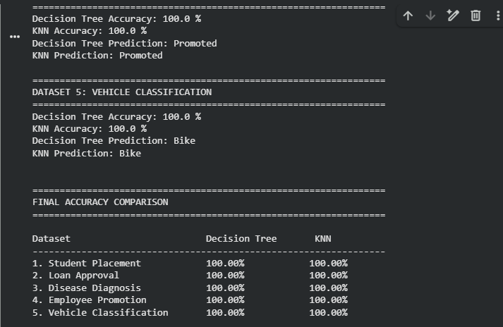

Result
The Decision Tree and KNN algorithms were successfully trained and tested on all five datasets. The accuracy of both classifiers was calculated and compared.
The new samples were classified as:
- Student Placement: Placed
- Loan Approval: Approved
- Disease Diagnosis: Positive
- Employee Promotion: Promoted
- Vehicle Classification: Bike
Thus, the performance of Decision Tree and KNN can be compared using their test accuracies, and the algorithm with the higher accuracy is considered the better-performing classifier for each dataset.

